Analyze Menu
Wireshark has two filtering languages: One used when capturing packets, and one used when displaying packets. In this section we explore that second type of filter: Display filters.
Display filters allow you to concentrate on the packets you are interested in while hiding the currently uninteresting ones. They allow you to select packets by:
- Protocol
- The presence of a field
- The values of fields
- A comparison between fields
- ... and a lot more

Defining and saving filters
You can define filters with Wireshark and give them labels for later use. This can save time in remembering and retyping some of the more complex filters you use.
To define a new filter or edit an existing one, select the Capture Filters... menu item from the Capture menu or the Display Filters... menu item from the Analyze menu. Wireshark will then pop up the Filters dialog as shown as below:-
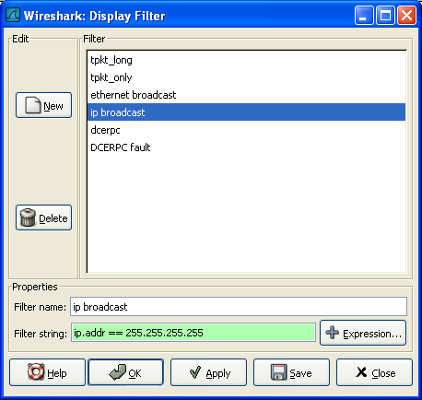

New
This button adds a new filter to the list of filters. The currently entered values from Filter name and Filter string will be used. If any of these fields are empty, it will be set to "new".
Delete
This button deletes the selected filter. It will be greyed out, if no filter is selected.
Filter
You can select a filter from this list (which will fill in the filter name and filter string in the fields down at the bottom of the dialog box).
Filter name:
You can change the name of the currently selected filter here.
Filter string:
You can change the filter string of the currently selected filter here. Display Filter only: the string will be syntax checked while you are typing.
Add Expression...
Display Filter only: This button brings up the Add Expression dialog box which assists in building filter strings.

OK
Display Filter only: This button applies the selected filter to the current display and closes the dialog.
Apply
Display Filter only: This button applies the selected filter to the current display, and keeps the dialog open.
Save
Save the current settings in this dialog.

To select packets based on protocol type, simply type the protocol in which you are interested in the Filter: field in the filter toolbar of the Wireshark window and press enter to initiate the filter.

FILTERING TCP PACKET:-

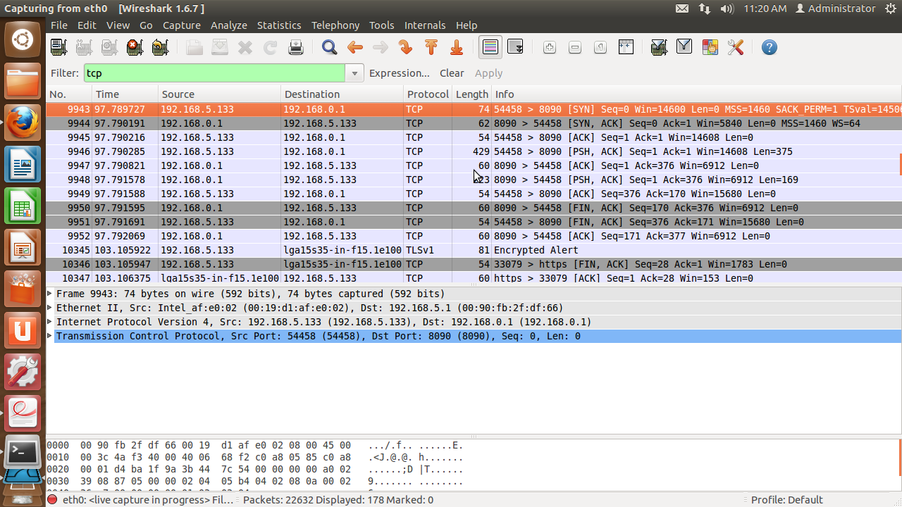

FILTERING ETHERNET ADDRESS:-

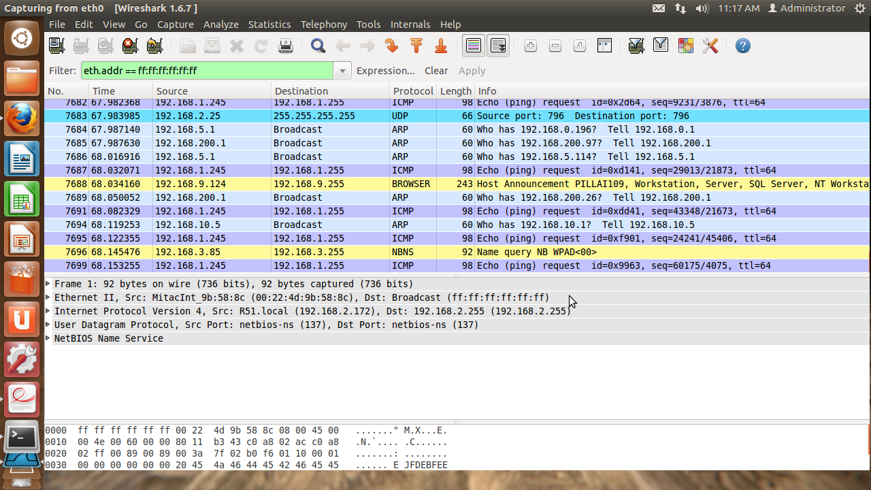

FILTERING HTTP PACKET:-

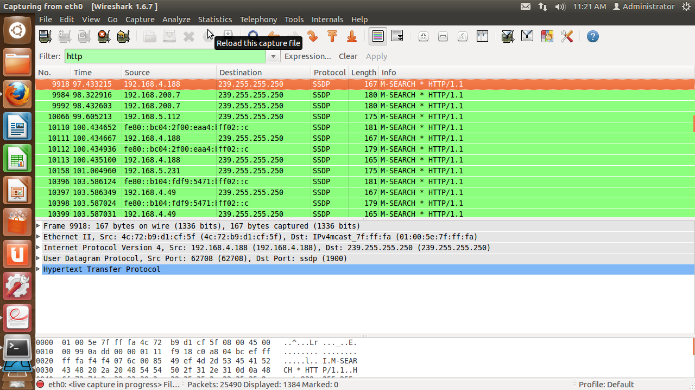
Defining and saving filter macros
You can define filter macros with Wireshark and give them labels for later use. This can save time in remembering and retyping some of the more complex filters you use.

START OF DISPLAYING FILTER MACROS:-

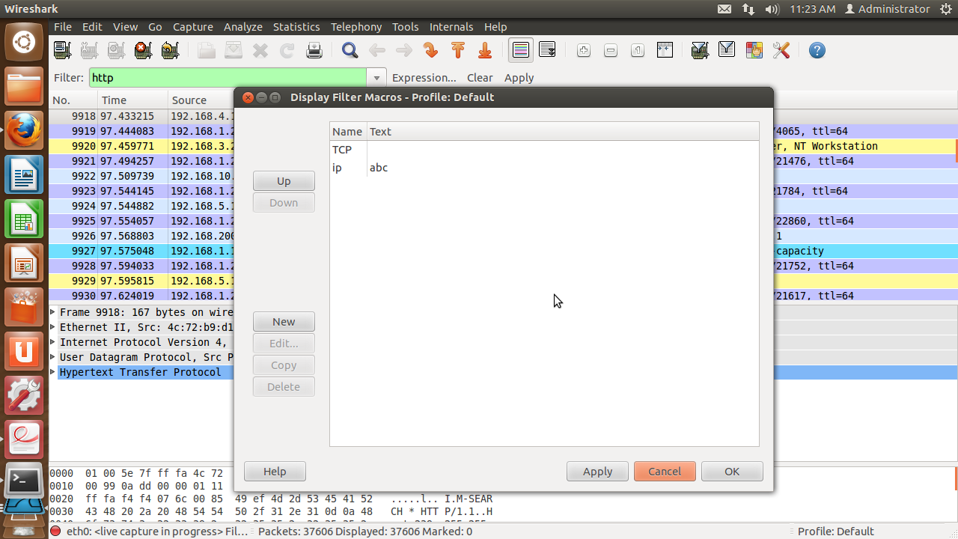

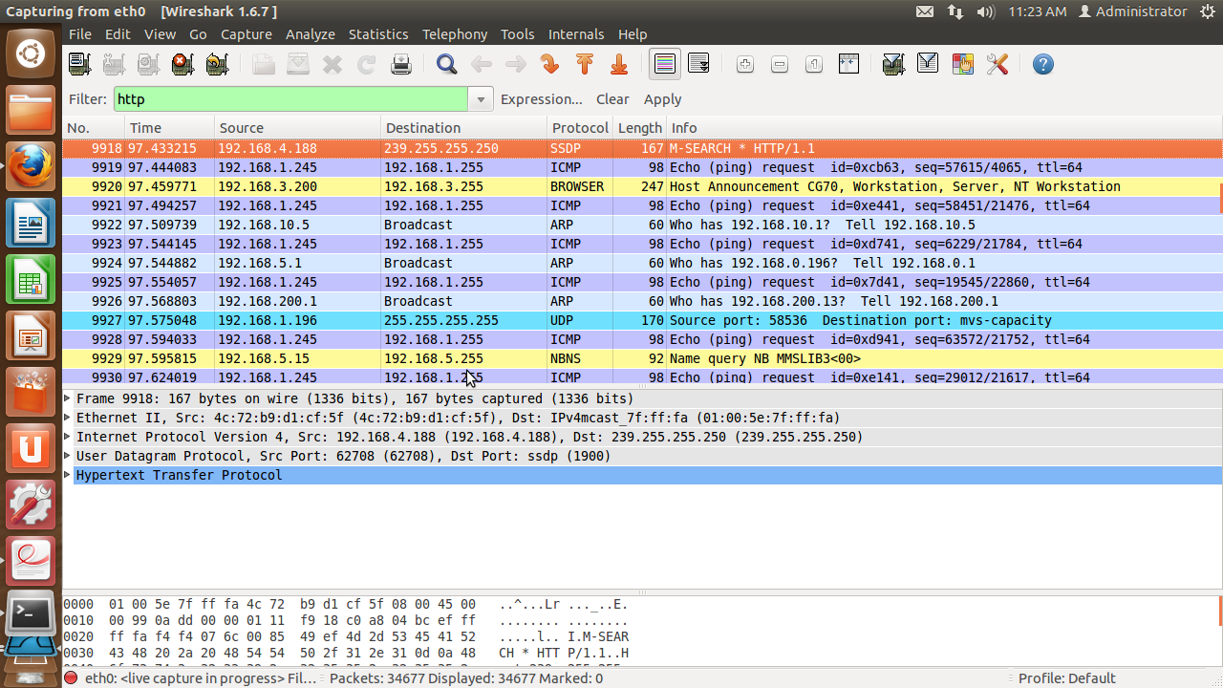
DISPLAYING FILTER MACROS:-

ENABLED PROTOCOLS:-

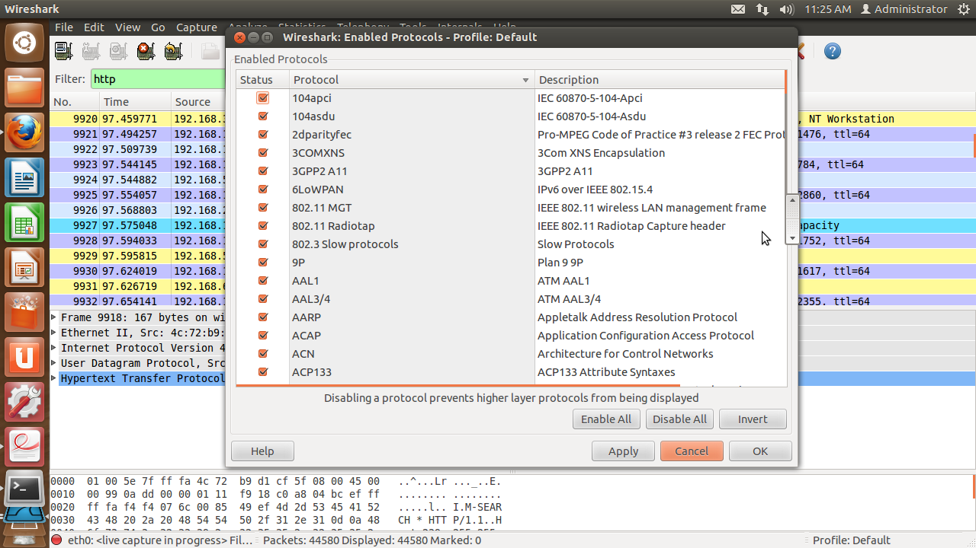

SNAPSHOT OF DECODE AS:-

Here any UDP source can be decoded into options such as ACTrace,ALC,AODV etc as shown below.
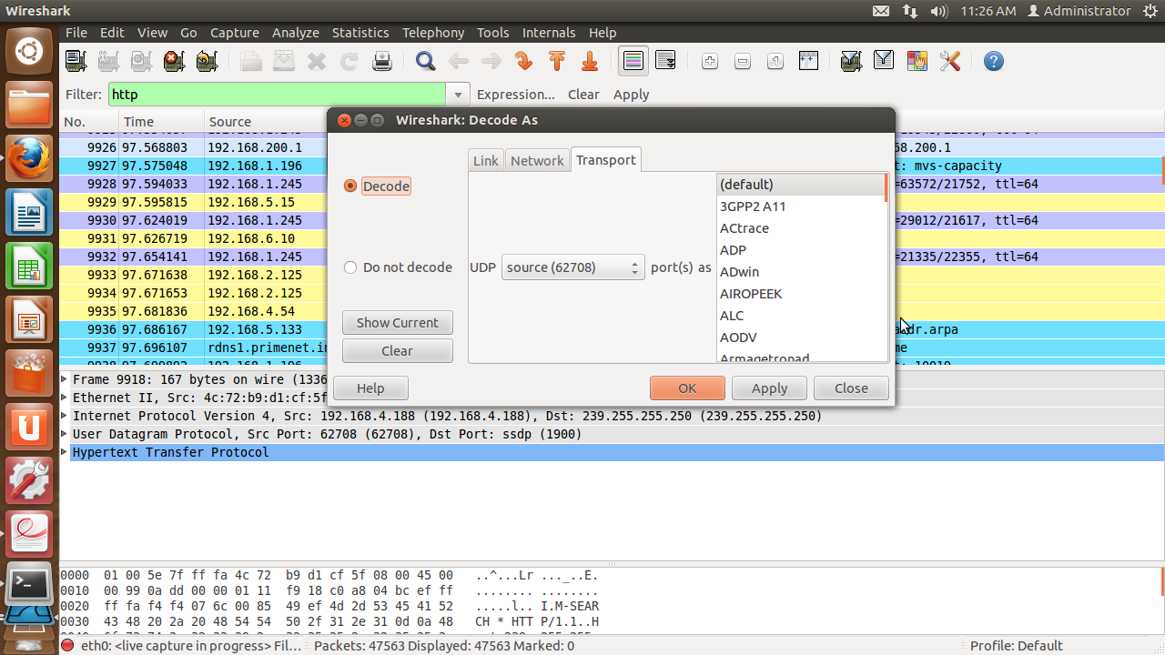

Similarly for destination also:-
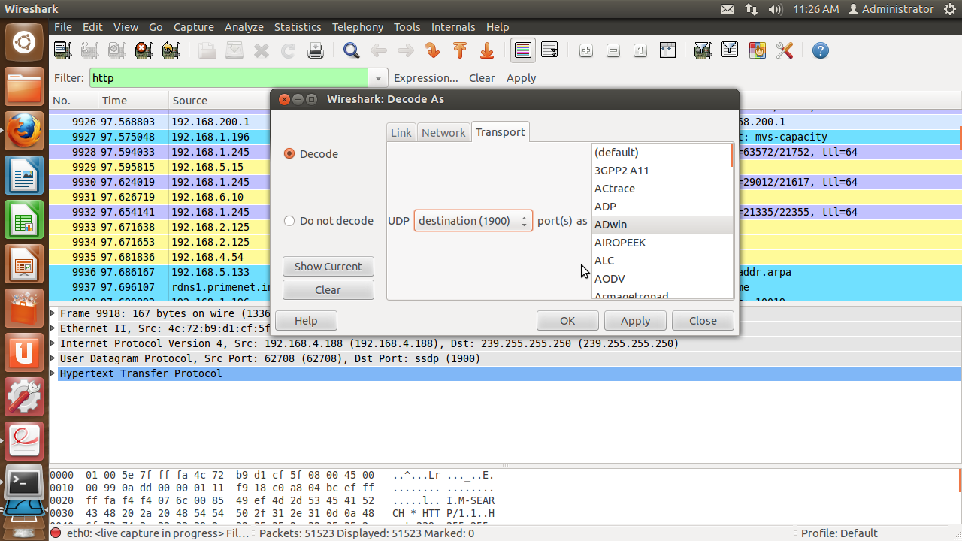
USER SPECIFIED DECODES:-

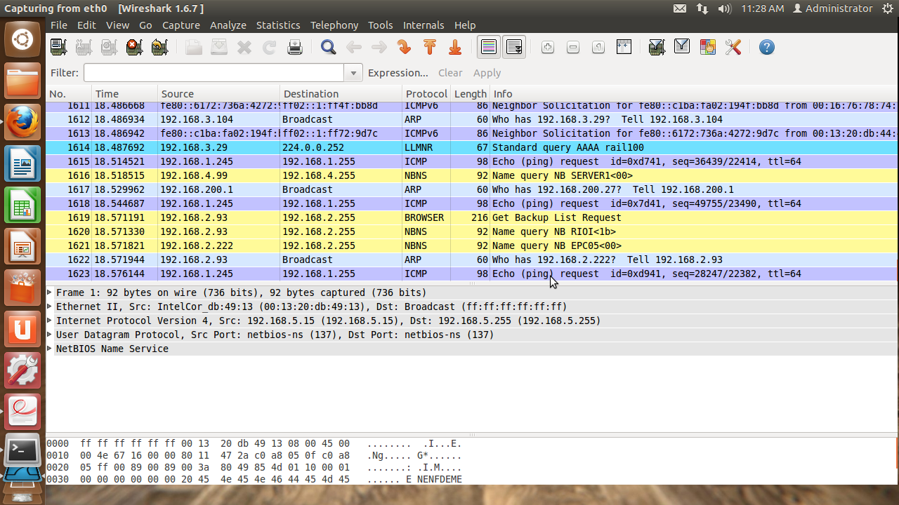

USER ENABLED PROTOCOLS:-

